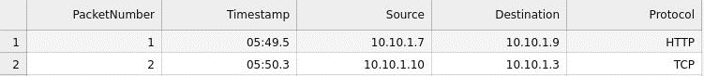This challenge involves analysing network traffic. I have been given a CSV file which contains information about packets traversing a network.

The tools I will be using is Jupyter notebook (currently my first time using it). Some of the key libraries that might help me are pandas and matplotlib.

**Question 1 - How many packets were captured?**

Since there is a column called packet number, I think it is fair to suggest that the packet number is how many were sent. I only assumed this because the CSV file looks like it is in sequential order.

This is the code I wrote and the ‘max_value’ variable should print out the largest packet number.

**Answer**: 100.

**Question 2 - What IP address sent the most amount of traffic during the packet capture?**

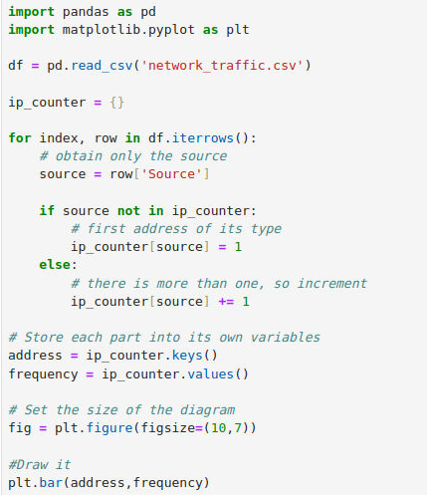

**Answer**: 10.10.1.4

**Question 3 – What is the most sent protocol?**

I did re-use my code above, I only changed the title of the column I was fetching.

This line of code says obtain all of the row values in the column ‘Protocol’.

**Answer**: ICMP